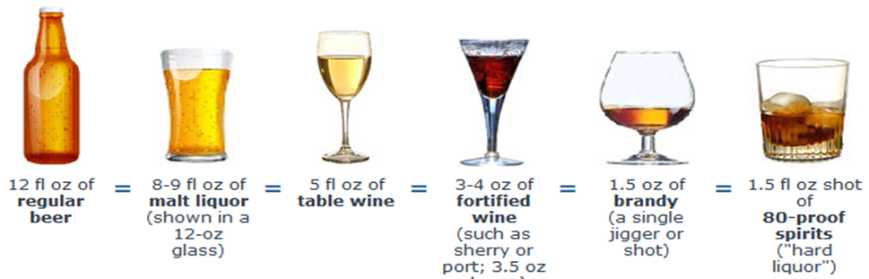
The Size of a Standard Drink:

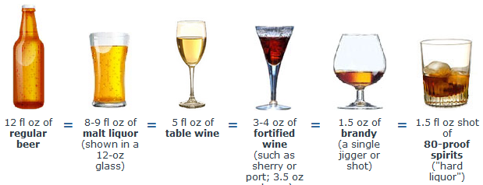
The Size of a Standard Drink:

